

Before using this document

This template has been made available to you for free.

Whilst you are welcome to use the documentation as you see fit, we strongly recommend that you take specific legal advice from the team at Primed as to the appropriateness of the documentation that you intend to issue in your particular set of circumstances. We promise we are very friendly!

In the event that you do use the documentation without first taking our advice, we need to be clear that in those circumstances, no relationship is created between you and any of the Outset Group Companies.

Please make a copy of this document for your reference and delete this page before issuing it.

About Primed

For brave & ambitious organisations, business never stops moving. Neither do the demands of HR & Health & Safety. We’re Primed, so you’re ready for whatever’s next. We advise, guide & support businesses with workplace compliance, HR & Health & Safety challenges, giving you the confidence to manage your people and safety with confidence.

To access more documents like this one or to find out more please book a free consultation here.

Risk Assessment – General Office

Company: |  | Risk Assessment Number: | RA / 090
Date: |  | Completed by:
Task: | General Office risk assessment | Site:
Task specific training required: |  | Permits required:
Equipment:

Residual Risk Calculator
Accident Probability |  | X | Accident Severity |  |  | = | Score | Factor | Action
Very Likely | 4 |  | Very Serious | 4 |  |  | 9 - 16 | High | Unacceptable Risk, Re-Assess to eliminate / reduce risk to low / med factor
Reasonably Likely | 3 |  | Reasonably Serious | 3
Reasonably Unlikely | 2 |  | Reasonably Moderate | 2 |  |  | 5 - 8 | Med | Consider further precautions to reduce risk to low factor.  Proceed with extra caution if unable to reduce risk level
Very Unlikely | 1 |  | Very Minor | 1 |  |  | 1 - 4 | Low | No Further Action required
Persons Affected (consider this in your assessment)
Employees |  |  |  |  | Visitors |  |  |  |  |  | Expectant Mother
Contractor Staff |  |  |  |  | General Public |  |  |  |  |  | Disabled Person
Client Staff |  |  |  |  | Young Person |  |  |  |  |  | Other

Identified Hazards | Key Risks | Results prior to controls |  |  |  | Existing Control Measures/Precautions | Results after controls |  |  |  | Additional Control Measures
 |  | Probability | Severity | Score | Factor |  | Probability | Severity | Score | Factor
Electrical | Use of faulty electrical equipment causing electrical shock, burns | 3 | 4 | 12 | High | Register kept of equipment on site.  Regular PAT testing organised for all portable electrical equipment. Any faults are rectified on identification.  Employees use of own equipment is discouraged | 2 | 2 | 4 | Low | Employees reminded to carry out pre-use checks and report any damage such as defective plugs, discoloured sockets or damaged cable/equipment
Cleaning of office areas | Slips trips and falls | 3 | 3 | 9 | High | Wherever possible cleaning is carried out during out of hours or quiet periods  All cleaning materials kept secure in locked cupboards.  Cleaning contractor provides safety data sheets and COSHH assessments for all hazardous materials.  Minimal quantities will be kept on site. | 2 | 2 | 4 | Low | Supervision and monitoring
Ignition Sources | Smoking, excess storage of comestibles | 3 | 4 | 12 | High | Smoking not allowed within the building  Fixed electrical system and portable electrical appliances subject to planned preventative maintenance and testing | 2 | 2 | 4 | Low | Prohibition of smoking signs in building  Supervision and monitoring
Welfare | Discomfort of employees due to inadequate welfare facilities | 2 | 3 | 6 | Med | Hot and cold water, soap, and means of drying hands provided – this will be adequate for the numbers on site  Adequate rest area where food can be heated also provided. Adequate toilets on site | 2 | 2 | 4 | Low | Weekly checks and monitoring of welfare facilities
Fire | Serious injuries, or fatalities, if persons become trapped by fire outbreak | 3 | 4 | 12 | High | Employees are informed of emergency procedures in the event of a fire. Fire marshals are available to assist in the evacuation of the building in the event of a fire.  Emergency routes to emergency exits, and the exits themselves, are kept clear at all times and lead as directly as possible to the open air or to a safe area | 2 | 2 | 4 | Low | Ensure Induction procedure is maintained and staff sign as confirmation  Weekly/Monthly checklists of fire doors and exits (Recorded)
Environment | Poor lighting to hot or too cold in the office | 3 | 2 | 6 | Med | Thermostatically controlled heating in office areas.  Lighting in all areas suitable for tasks being conducted | 2 | 2 | 4 | Low | Annual maintenance regime
DSE | Repetitive strain syndrome | 3 | 3 | 9 | High | DSE training for identified staff | 2 | 2 | 4 | Low | Review annually

TASK PPE ASSESSMENT
STANDARD MANDATORY PPE: | 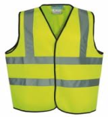  HIVIZ |   TOE CAP BOOTS  BS EN 345 Steel | 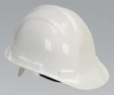  BS EN 397 | 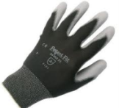  BS EN 388  4121 | 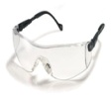  EN166 Grade1
TICK BOX:
GLOVES OPTIONS: | 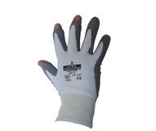  TOUGH  BS EN 388  4343 | CHEMICAL  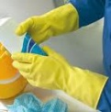  BS EN 374 | FALL PROTECTION: | 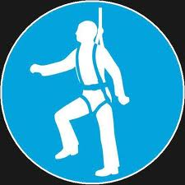  HARNESS & LANYARD | SAFETY NET / AIRBAG
TICK BOX: |  |  | TICK BOX:
EYE PROTECTION OPTIONS: | 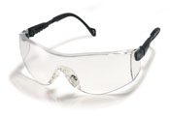  BS EN 166 grade1 | 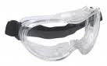  BS EN166  grade 2 | DUST MASK OPTIONS: | 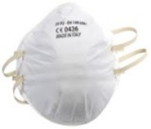  class: FFP2  Filters at least 94% of airborne particles | 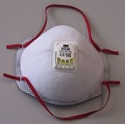  class: FFP3  Filters at least 99.95% of airborne particles
TICK BOX: |  |  | TICK BOX:
GENERAL (must always be worn) | 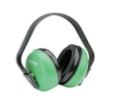  BS EN 352 Earmuffs  (If noise levels reach over 85db) | BS EN 352 Ear plugs  (If noise levels reach 80 db)  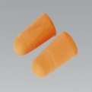 | EXTRA OPTIONS: | LONG SLEEVED TOP / OVERALLS | OTHER
TICK BOX: |  |  | TICK BOX:

Assessed By: |  | Reviewed by: |  | Reviewed by:
Position: |  | Position: |  | Position:
Signature: |  | Signature: |  | Signature:
Date: |  | Date: |  | Date:

